Application of Sampling in TDM

If we have multiple BASEBAND signals that we would like to transmit over the same channel such as a coaxial cable or a wireless channel, one method of being able to transmit all channels and yet being able to extract each channel at the receiver without interference between the different signals is to modulate each channel at a different frequency. It is obvious in this case that the different channels are sharing the same transmission time (all are transmitted at the same time) but they divide the frequency band (because each has its own transmission band that resulted from modulating each at a different frequency). These channels are said to be Frequency Division Multiplexed (FDM). This is the process that is used for transmitting multiple radio channels in the AM or FM bands and multiple TV channels over a satellite. In many cases, we would like to transmit multiple signals over the same communication channels without modulating the signals first. Therefore, we have to use time–division multiplexing (TDM). TDM is a process in which different signals that have the same frequency are transmitted over the same channel. These signals instead of being multiplexed in frequency, they are multiplexed in time. One method for performing TDM is to sample the different signals at the same rate but at different time instants and the samples of the different signals are interleaved (placed in a sequence). Consider for example the three signals represent by the dashed lines shown below.
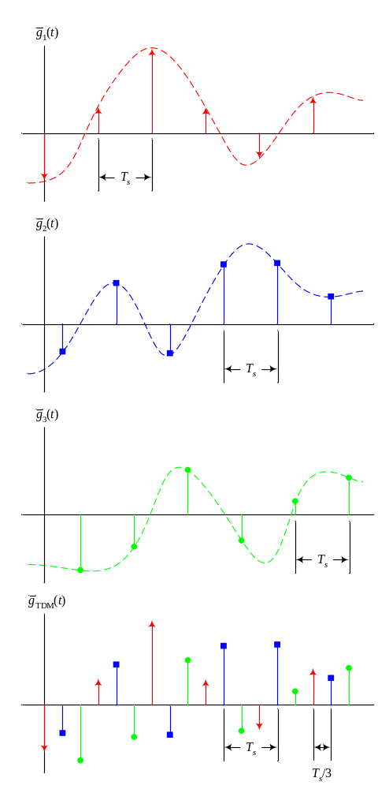

The signal containing the samples of the different original signals is a TDM signal. This signal can be transmitted over a channel and the received samples can be DE–INTERLEAVED (samples are separated to create the original signals). It is clear that TDM cannot be performed for continuous time signals.

Pulse Modulated Signals

Since ideal delta function cannot be implemented in practice, representing samples of signals in terms of delta functions is only theoretical. Therefore, one practical method for representing samples is using pulses (rect functions) instead of impulses (delta functions). There are three main types using which we represent the information carried by a sequence of samples (three types of pulse modulations). Notice that the term “modulation” here is not used in the sense of modulation that we used in the previous chapters, which the frequency of a signal is shifted to a higher frequency for transmission. The term modulation here is used to specify the process in which the information signal modifies some parameter of a sequence of pulses. This parameter is used to transmit the desired information.

Pulse Amplitude Modulation (PAM): in this modulation scheme, the information is carrier in the amplitude (or height) of the pulses. This is the most logical pulse modulation method. The following shows an example of PAM. Notice that the width of the different pulses is exactly the same and that the pulses are always centered at the sampling instants (or may start at the sampling instants), but there centers are always separated by the sampling period T_{s}.

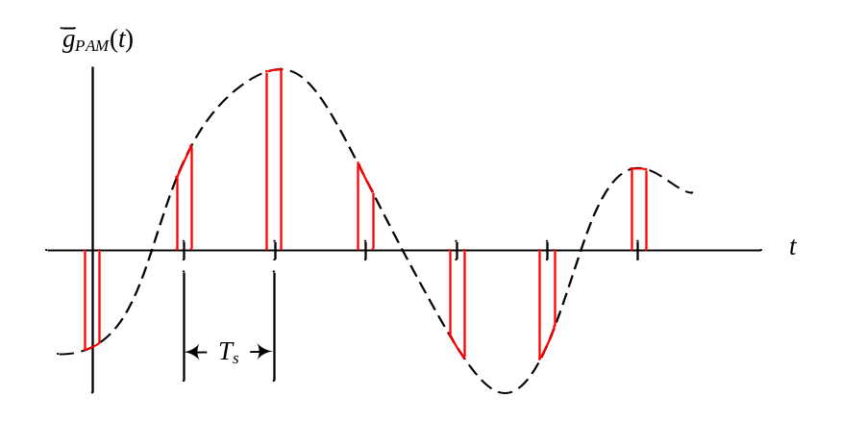

Pulse–Width Modulation (PWM): in this modulation, the information is carrier in the width (or duration) of the pulses. The following shows an example of PWM. Notice that the height (amplitude) of the different pulses is exactly the same and that the pulses are always centered at the sampling instants and separated by the sampling period T_{s}.

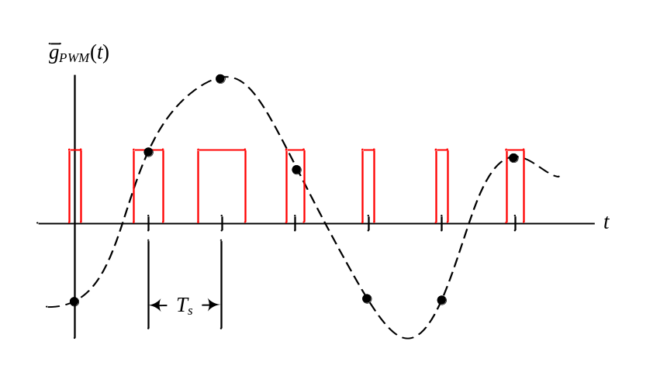
Pulse–Position Modulation (PPM): in this modulation, the information is carrier in the position of the pulses. The following shows an example of PPM. Notice that the height (amplitude) and width of the different pulses is exactly the same. Here the pulses are not centered at sampling instants.
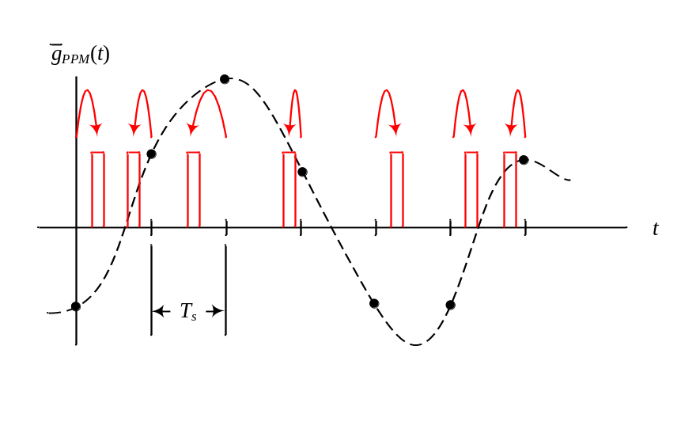
Comment: Each of the above pulse modulation methods has advantages and disadvantages. For example, the advantage of PPM and PWD over PAM is that they have constant amplitude. For transmissions over channels that change with time (called time–varying channels) the gain of the channels may change, and therefore the height of the pulses may change not because they were amplitude modulated, but because the power received as different pulses were transmitted was varying because of the distance. If the transmitted pulses originally had constant height as it is the case for PPM and PWM, even if the received pulses had varying amplitudes, the varying amplitude has no effect on the receiver. This is generally not possible if PAM was used. On the other hand, it is clear that if the amplitude of the original continuous-time signal suddenly became large, the width of pulses in PWM may either increase to overlap with adjacent pulses or collapse to become zero. In this case, the receiver may get confused on what the original continuous-time signal was. A similar problem may occur in PPM where pulses that were generated later could precede pulses that were generated first because of high amplitude of the input continuous-time signal.
Pulse Code Modulation (PCM)

The modulation methods PAM, PWM, and PPM discussed in the previous lecture still represent analog communication signals since the height, width, and position of the PAM, PWM, and PPM, respectively, can take any value in a range of values. Digital communication systems require the transmission of a digital for of the samples of the information signal. Therefore, a device that converts the analog samples of the message signal to digital form would be required. Analog to Digital Converters (ADC) are such devices. ADCs sample the input signal and then apply a process called quantization. The quantized forms of the samples are then converted to binary digits and are outputted in the form of 1’s and 0’s. The sequence of 1’s and 0’s outputted by the ADC is called a PCM signal (Pulses have been coded to 1’s and 0’s).

Example: A color scanner is scanning a picture of height 11 inches and width 8.5 inches (Letter size paper). The resolution of the scanner is 600 dots per inch (dpi) in each dimension and the picture will be quantized using 256 levels per each color. Find the time it would require to transmit this picture using a modem of speed 56 k bits per second (kbps).

We need to find the total number of bits that will represent the picture. We know that 256 quantization levels require 8 bits to represent each quantization level.

Number of bits = 11 inches (height) * 8.5 inches (width) * 600 dots / inch (height) * 600 dots / inch (width) * 3 colors (red, green, blue)
* 8 bits / color = 807,840,000 bits
Using a 56 kbps modem would require 807,840,000 / 56,000 = 14426 seconds of transmission time = 4 hours.
For this reason, compression techniques are generally used to store and transmit pictures over slow transmission channels.

